ACADEMIC YEAR
2024-2025
ODD SEM
NEWS LETTER
July 2024 – Jan 2025

ABSTRACT

PATENT REGISTERED
DATE | TOPIC | Published by
18-10-2024 | Optimizing EV charging station operations using IOT, Cloud Computing & Machine Learning for Eco-friendly Transportation | Mrs. M. Shunmuga Sankari – HOD/EEE  Mr. T. Kamalkumar – AP/EEE  Mr. M. Arjunkumar – AP/EEE  Mr. S. Ganesh – AP/EEE

FACULTY FDP’S
SL.NO | STAFF NAME | EVENT NAME | CONDUCTED BY | DURATION
1 | Mr.T.Kamalkumar – AP/EEE | Cutting-Edge Research Technologies in Signal Processing using MATLAB | MLRIT, Hyderabad | 12-08-2024 to 17-08-2024
2 | Mrs.M.Shunmuga Sankari – HOD/EEE  Mr.T.Kamalkumar – AP/EEE | IP Awareness program | NATIONAL INTELLECTUAL PROPERTY AWARENESS MISSION (NIPAM) | 23-08-2024
3 | Mr.T.Kamalkumar – AP/EEE | NAAN MUDHALVAN PROGRAMME | Microsoft Digital Skills course | 16-09-2024 TO 21-09-2024
4 | Mrs.M.Shunmuga Sankari – HOD/EEE  Mr.T.Kamalkumar – AP/EEE | Smart Grid and Renewable Energy Sources | St. Josephs College of Engineering, OMR, Chennai | 23-09-2024 TO 27-09-2024
5 | Mrs.M.Shunmuga Sankari – HOD/EEE  Mr.T.Kamalkumar – AP/EEE  Mr. M. Arjunkumar – AP/EEE  Mr. S. Ganesh – AP/EEE | RECENT ADVANCEMENTS IN AI & IOT – INDUSTRY PERSPECTIVE | Periyar maniammai Inst of Science & Tech (PMIST), Vallam | 25-11-2024 TO 30-11-2024
6 | Dr. J. PRAKASH – Principal  Mrs.M.Shunmuga Sankari – HOD/EEE  Mr.T.Kamalkumar – AP/EEE  Mr. M. Arjunkumar – AP/EEE  Mr. S. Ganesh – AP/EEE | CLIMATIC CRISIS AND MITIGATION BY SUSTAINABLE DEVELOPMENT OF ENERGY AND ENVIRONMENT SYSTEMS | ATAL – SRI KRISHNA COLLEGE OF ENGG & TECH , COIMBATORE | 16-12-2024 TO 21-12-2024
7 | Mrs.M.Shunmuga Sankari – HOD/EEE  Mr.T.Kamalkumar – AP/EEE  Mr. M. Arjunkumar – AP/EEE  Mr. S. Ganesh – AP/EEE | 6-day Faculty Development Programme on “Smart Grid  and Smart Distribution System | Mailam Engg College Villupuram | 16.12.2024 TO 21.12.2024

INDUSTRIAL VISITS
S.NO | NAME OF THE ORGANISATION | PARTICIPATED STUDENTS | DATE
1 | ISRO,SRIHARIKOTA | II,III & IV | 16-08-2024
2 | DAIKIN Air conditioning and Development Center, Sricity,Tada | II & III | 09-09-2024
3 | AXIS GLOBAL INSTITUTE OF INDUSTRIAL TRAINING in Guindy | II,III & IV | 18-10-2024

STUDENT OTHER EVENTS
S.NO | DATE | NAME OF THE EVENT | VENUE | PARTICIPATED STUDENTS
1 | 02-09-2024  09-09-2024  16-09-2024  23-09-2024  07-10-2024  21-10-2024 | Naan Mudhalvan Course | Velammal Institute of Technology, Thachoor. | IV –EEE STUDENTS
2 | 04-09-2024 | Blood Donation camp | Mercy Educational & Charitable Trust from Anna Nagar | II-EEE (2) & IV-EEE (6) STUDENTS
3 | 09-10-2024 | Naan Mudhalvan State-Wide Placement Program | Tagore Engineering College. | IV-EEE STUDENTS
4 | 21-01-2025 | Naan Mudhalvan Course - Niral Thiruvizha 2.0 | T.J.S. Engineering college, Peruvoyal | IV-EEE STUDENTS

DATE | Presented by | Attended by
22-10-2024 | GLOBAL TECH PVT LTD | III year students
21-01-2025 | PROLIFIC SYSTEMS & TECH PVT LTD | II,III & IV year students
GUEST LECTURE

TECHNICAL SEMINAR

DATE | Presented by | Attended by
22-10-2024 & 24-10-2024 & 25-10-2024 | Mr.ANANTHARAMAN (PROLIFIC) | II year students

WORKSHOP
DATE | Presented by | Attended by
29-10-2024 | Axis global institute of industrial training | II,III & IV YEAR STUDENTS

INTERNSHIP
DATE | Presented by | Attended by
27-01-2025 TO 10-02-2025 | Prolific Systems & Technologies Pvt. Ltd | II Year Students (21 No.s)

ALUMNI INTERACTION
DATE | ALUMNI NAME | DESIGNATION
17-10-2024 | Mr.Sivakumar | Software Engineer, TCS
25-11-2024 | Mr.Naresh kumar  Mr.Sathish kumar | Software Engineer, TCS  Sr.Electrical Engineer,Gummidipoondi
07-12-2024 | Mr. Gaddam Sathish | Sr.System Admin,Aquarelle India

TNSCST PROJECT PROPOSAL
DATE | EVENT NAME | NO. OF BATCH
12-09-2024 | SMART INDIA HACKETHON | 04
13-09-2024 | Tamil Nadu State Council for Science and Technology | 05

12-08-2024 to 17-08-2024
Mr.T.Kamal kumar – AP/EEE as a participant in the online FDP on “Cutting-Edge Research Technologies in Signal Processing using MATLAB” held from 12th to 17th August 2024 conducted by MLRIT, Hyderabad

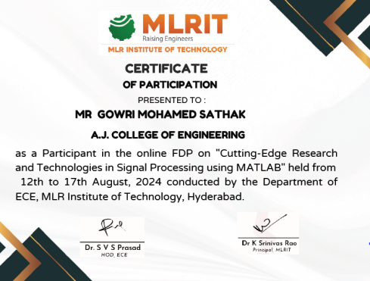

16-08-2024
Industrial Visit for the students of the II, III & IV year to display the ROCKET LAUNCHING by ISRO with the co-ordination of following faculties,
- Mr.T.KAMAL KUMAR – AP/EEE
- Mr.M.ARJUNKUMAR - AP/EEE
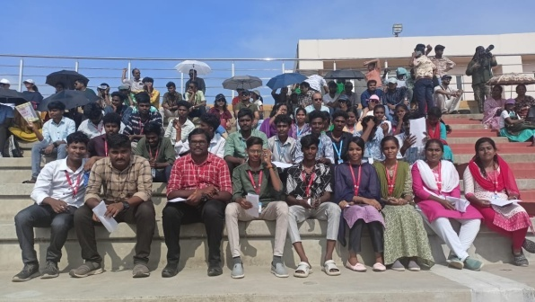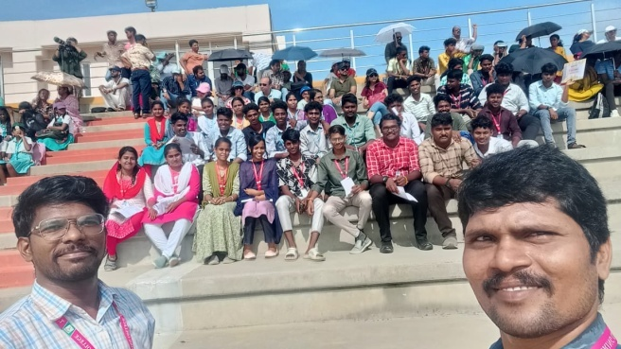
19-08-2024
Naan Mudhalvan Course conducted for IV year students on VELAMMAL Engineering College, Thachoor with the co-ordination of Mr.M.Arjunkumar – AP/EEE
20-08-2024
Naan Mudhalvan Course conducted for III year students in online withtheir mobile on respective places with the co-ordination of Mr.T.Kamal kumar – AP/EEE
23-08-2024
The following faculties attended the IP Awareness program under NATIONAL INTELLECTUAL PROPERTY AWARENESS MISSION (NIPAM)
Mrs.M.Shunmuga Sankari – HOD/EEE
Mr.T.Kamal kumar – AP/EEE
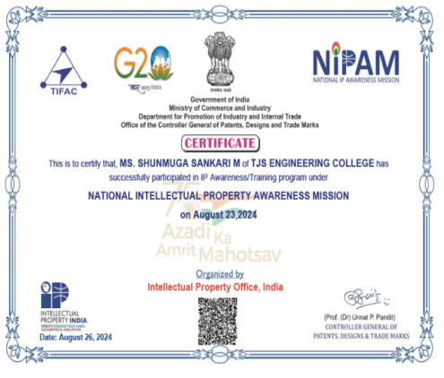
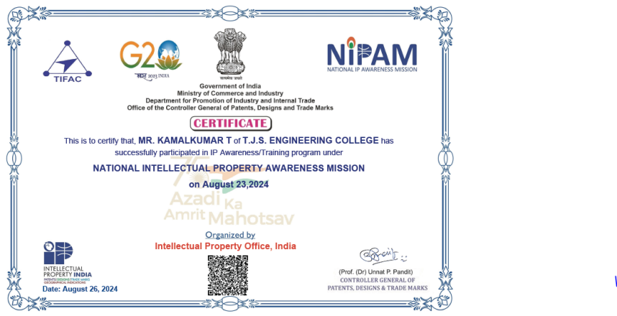

27-08-2024
Naan Mudhalvan Course conducted for III year students on TJS Engineering College, peruvayal with the co-ordination of Mr.T.Kamal kumar – AP/EEE
02-09-2024
Naan Mudhalvan Course conducted for IV year students on VELAMMAL Engineering College, Thachoor with the co-ordination of Mr.M.Arjunkumar –AP/EEE
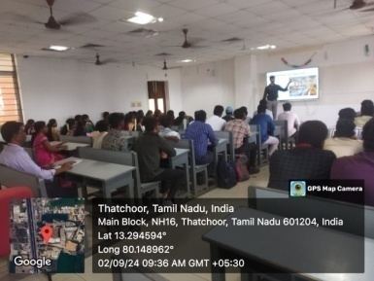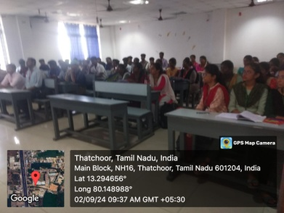
03-09-2024
Naan Mudhalvan Course conducted for III year students on TJS Engineering College, peruvayal with the co-ordination of MR.T.Kamal kumar – AP/EEE
04-09-2024
Chennai Blood Centre run by Mercy Educational & Charitable Trust from Anna Nagar conducted a Blood Donation camp in our college campus. Our dept students were also participate to donate blood list of that students list has been mentioned below
- PERARASU.K (II)
- VIJAYAKUMAR.V (II)
- K.N.GANESH KUMAR (IV)
- SACHINKUMAR.S (IV)
- KARTHICK.N (IV)
- MUTHUVIJAYAN.S (IV)
- SAI YESHWIN.S (IV)
- YUVANRAJ.T (IV)
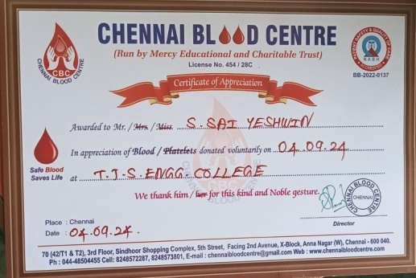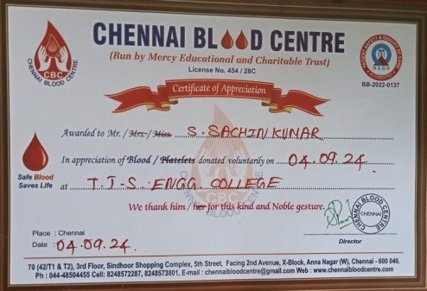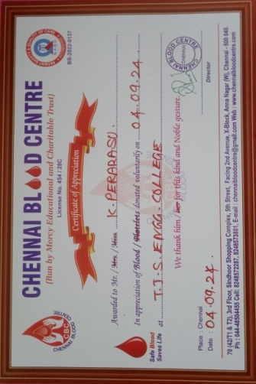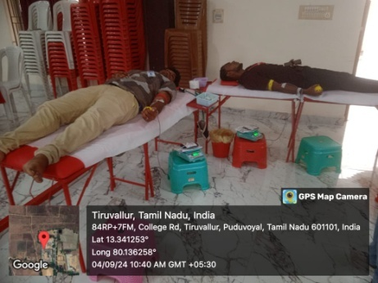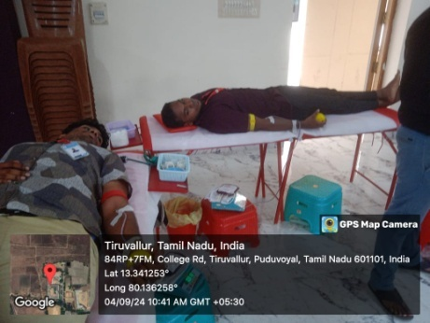

05-09-2024
Smart India Hackathon project proposal conducted for 3 batch of students from the IV year with the co-ordination of Mr.T.Kamal kumar – AP/EEE

06-09-2024
TANSCST project proposal registered in online and hard copy to be submitted on 10-09-2024 with the 8 batch of students from IV year with the co-ordination of Mr.T.Kamal kumar – AP/EEE

09-09-2024
II & III year students has been taken to the INDUSTRIAL VISIT for the ACDC (DAIKIN Air conditioning and Development Center,Sricity,Tada) with the co-ordination of T.Kamal kumar – AP/EEE & K.Shanmugaraj – LI/EEE
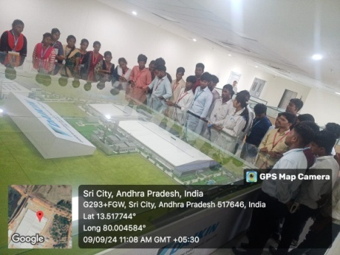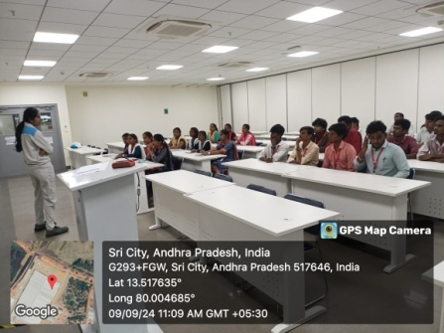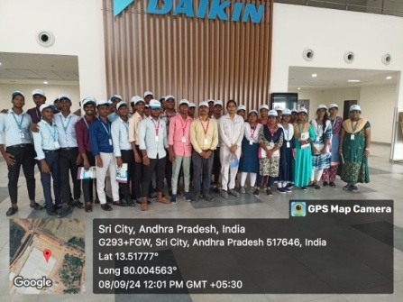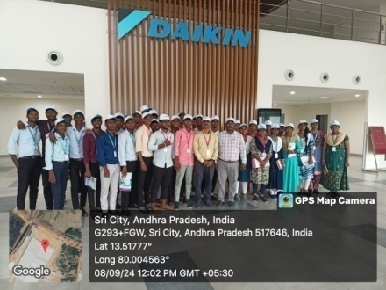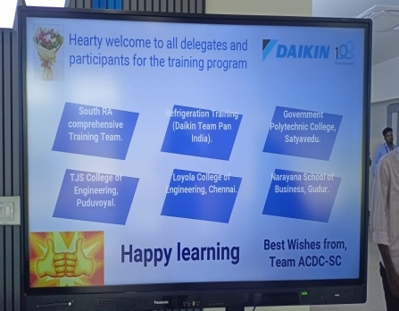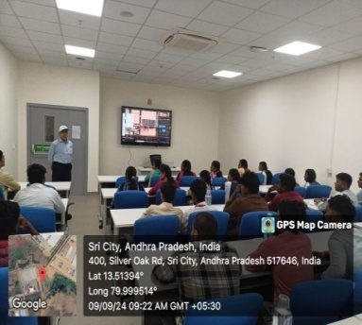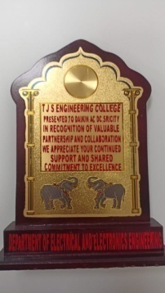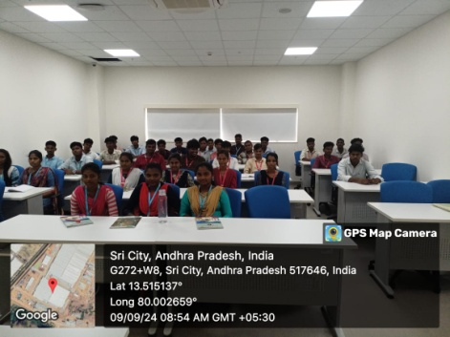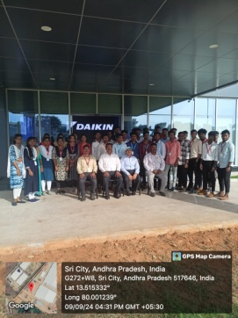

09-09-2024
IV year students has been attended the NAAN MUDHALVAN course in Vellammal College of Engg & Tech in Thatchoor with the co-ordination of Neelagandan – LI/EEE
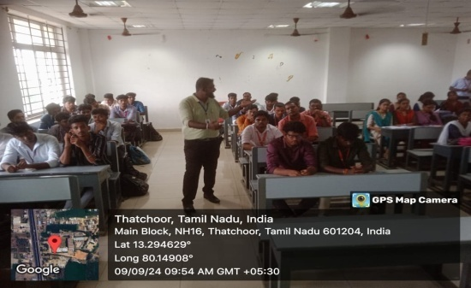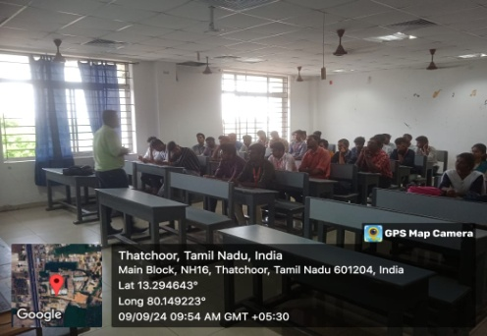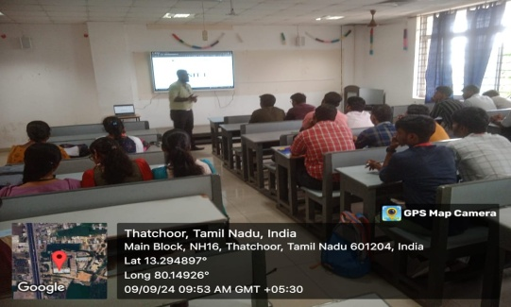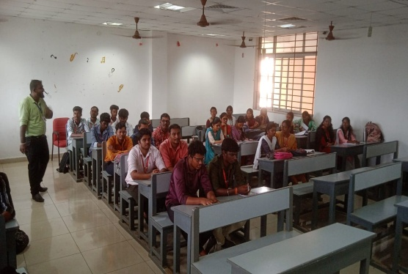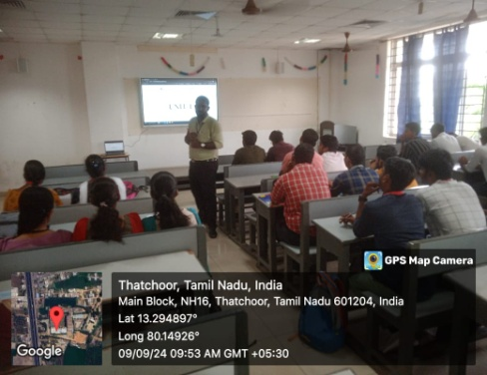
10-09-2024
III year students attended the NAAN MUDHAVALAN course in online at our college campus with the co-ordination of T.Kamal kumar– AP/EEE
10-09-2024
IV year students Udhayakumaran B &Vayuluru mouli went for Anna University to submit the TNSCST Project proposal from guidance of T.Kamal kumar – AP/EEE
12-09-2024
- 4 Projects proposal submitted by EEE Department Students in SMART INDIA HACKETHON

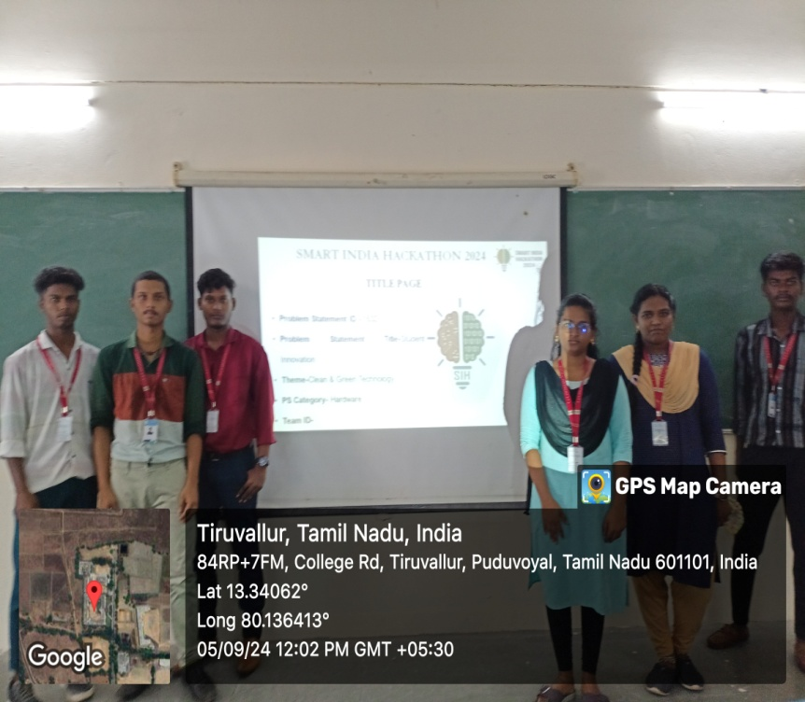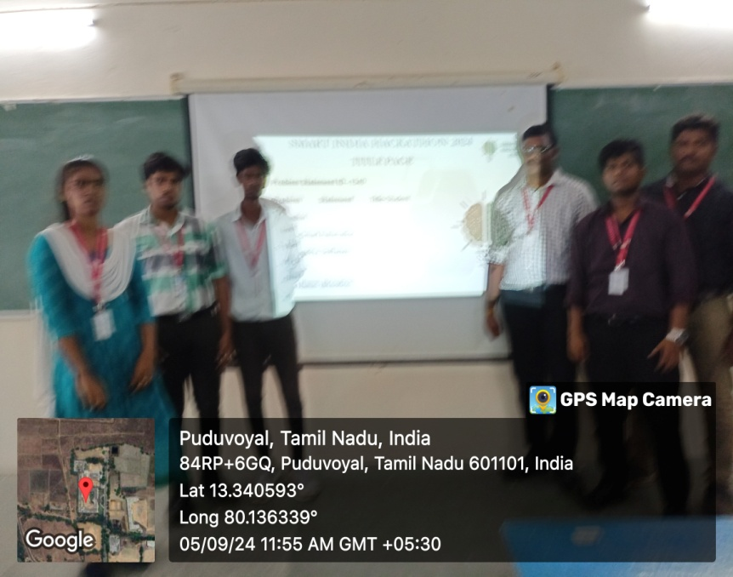
13-09-2024
IV EEE Students -5 Batches Submitted the Proposal For Tamil Nadu State Council for Science and Technology (TNSCST) Project
14-09-2024
Fresher’s Day program conducted for 2024-2025 batch students by the Management

16-09-2024
IV year students has been attended the NAAN MUDHALVAN course in Vellammal College of Engg & Tech in Thatchoor with the co-ordination of Neelagandan – LI/EEE
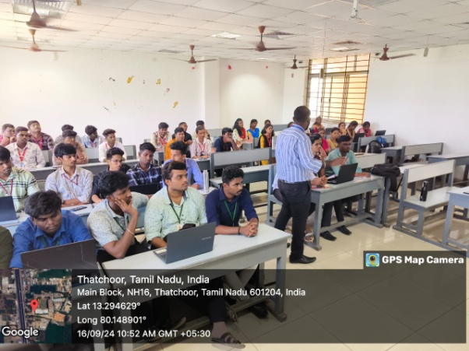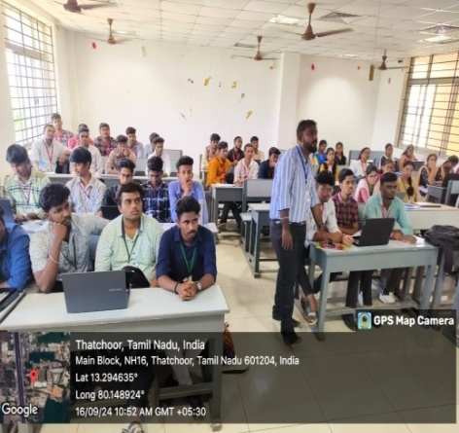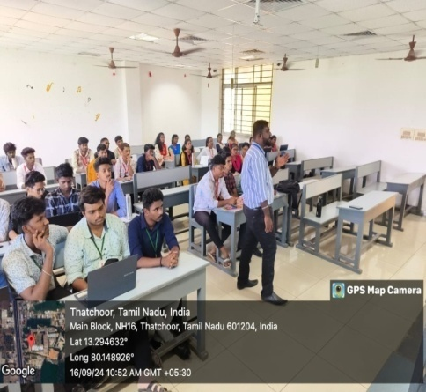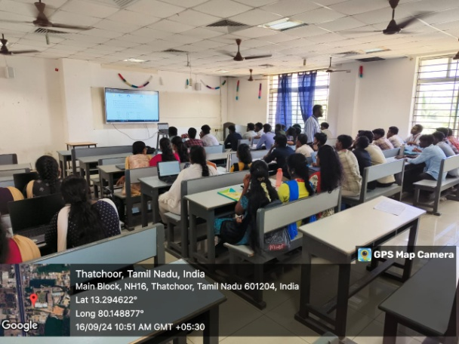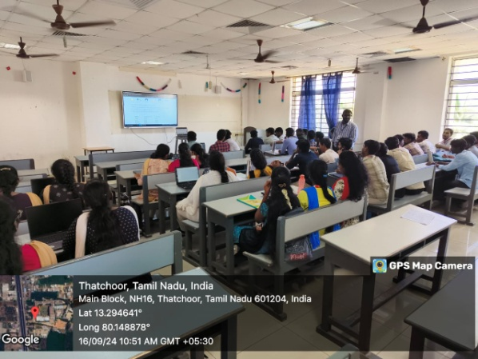

16-09-2024 TO 21-09-2024
FDP on NAAN MUDHALVAN PROGRAMME on Microsoft Digital Skills course with A grade held at ANNA UNIVERSITY by
Mr. T. Kamal kumar – AP/EEE

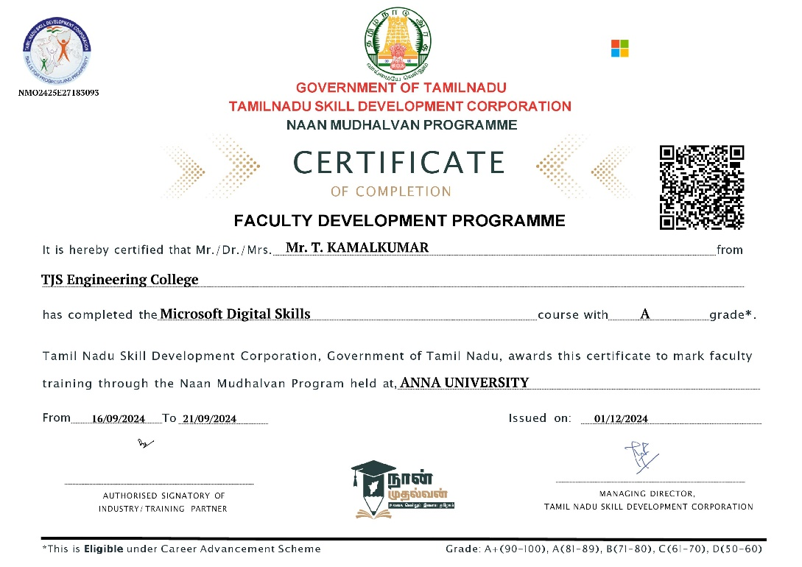

23-09-2024
IV year students has been attended the NAAN MUDHALVAN course in Vellammal College of Engg & Tech in Thatchoor with the co-ordination of Neelagandan – LI/EEE
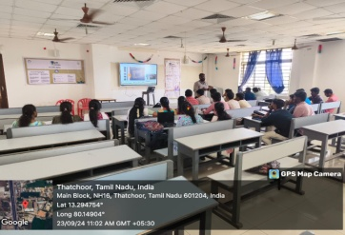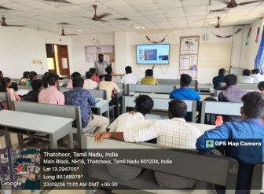
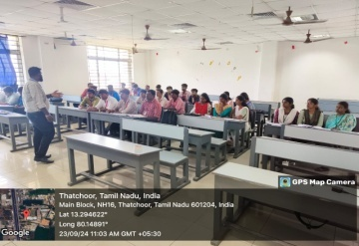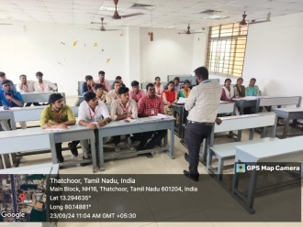

23-09-2024 TO 27-09-2024
M.SHUNMUGA SHANKARI HOD – EEE & T.KAMAL KUMAR AP – EEE Participated in the AICTE Recognized Faculty Development Program on Smart Grid and Renewable Energy Sources Conducted by Electrical Engineering Department at St. Josephs College of Engineering, OMR, Chennai
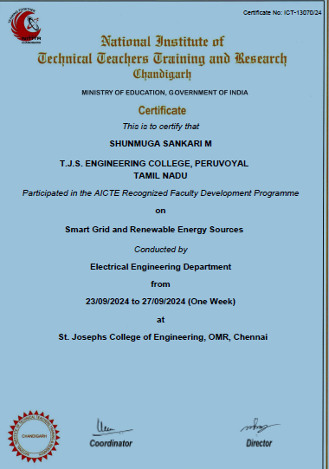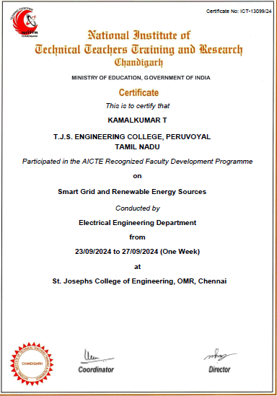

07-10-2024
IV year students has been attended the NAAN MUDHALVAN course in Vellammal College of Engg & Tech in Thatchoor with the co-ordination of Neelagandan – LI/EEE
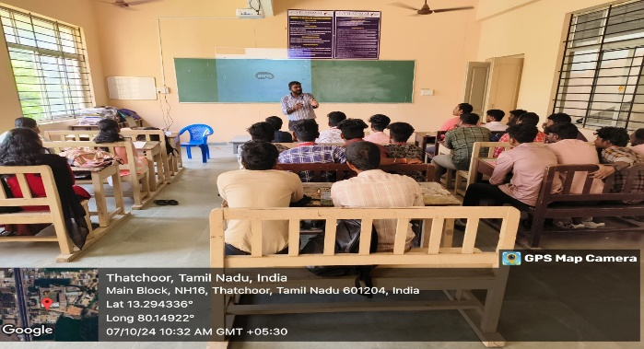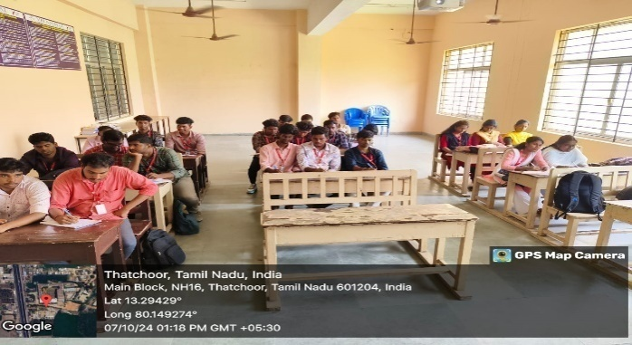
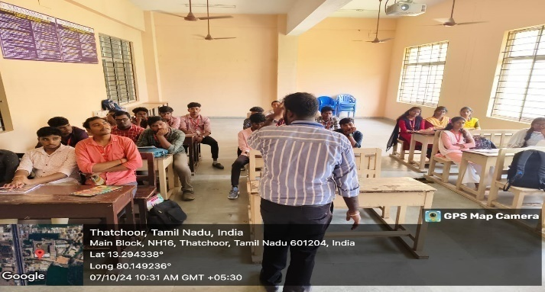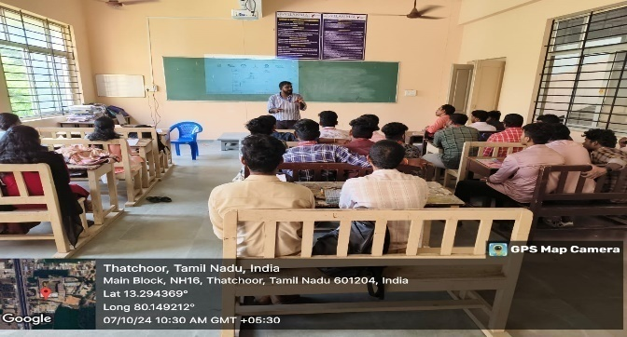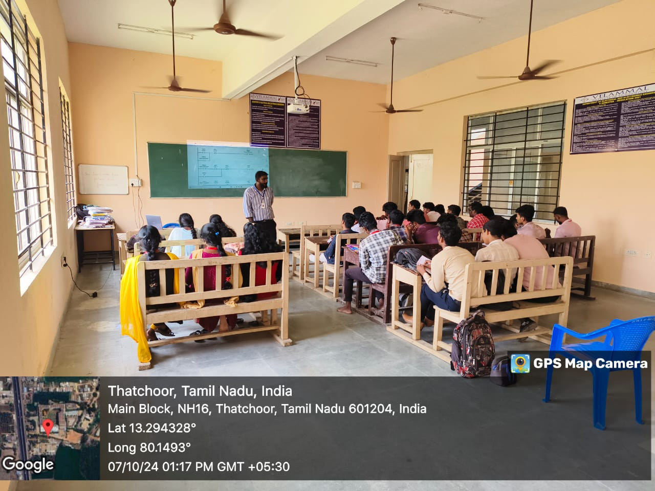
08-10-2024
III year students has been attended the NAAN MUDHALVAN course in our college through online mode in CAD lab with the co-ordination of T.Kamal kumar – AP/EEE
08-10-2024
PATENT REGISTERED on Optimizing EV charging station operations using IOT, Cloud Computing & Machine Learning for Eco-friendly Transportation by
Mrs. M. Shunmuga Sankari – HOD/EEE
Mr. T. Kamalkumar – AP/EEE
Mr. M. Arjunkumar – AP/EEE
Mr. S. Ganesh – AP/EEE
09-10-2024
II year students has been attended the NAAN MUDHALVAN course in our college through online mode in there respected class room with the co-ordination of T.Kamal kumar – AP/EEE

09-10-2024
IV year students has been attended the NAAN MUDHALVAN STATE-WIDE PLACEMENT PROGRAM in TAGORE ENGINEERING COLLEGE, Vengambakkam
List of Students
- V.MOULI
- UDHAYAKUMARAN
- VIJAY.B
- NANDHINI.S
- DHASVANTH
- JANCY RANI.K
- PRIYADHARSHINI.S
- PRATHEEP KUMAR.M
- KAMALESH.G
- SAI YESHWIN.S
- YUVANRAJ.T
- PRASANTH.R
- VISWANATHAN.C
- MUTHUVIJAYAN.S

17-10-2024
Alumni meet-up arranged for 2nd , 3rd and 4th year students of EEE dept. by Sivakumar 2022 passed out

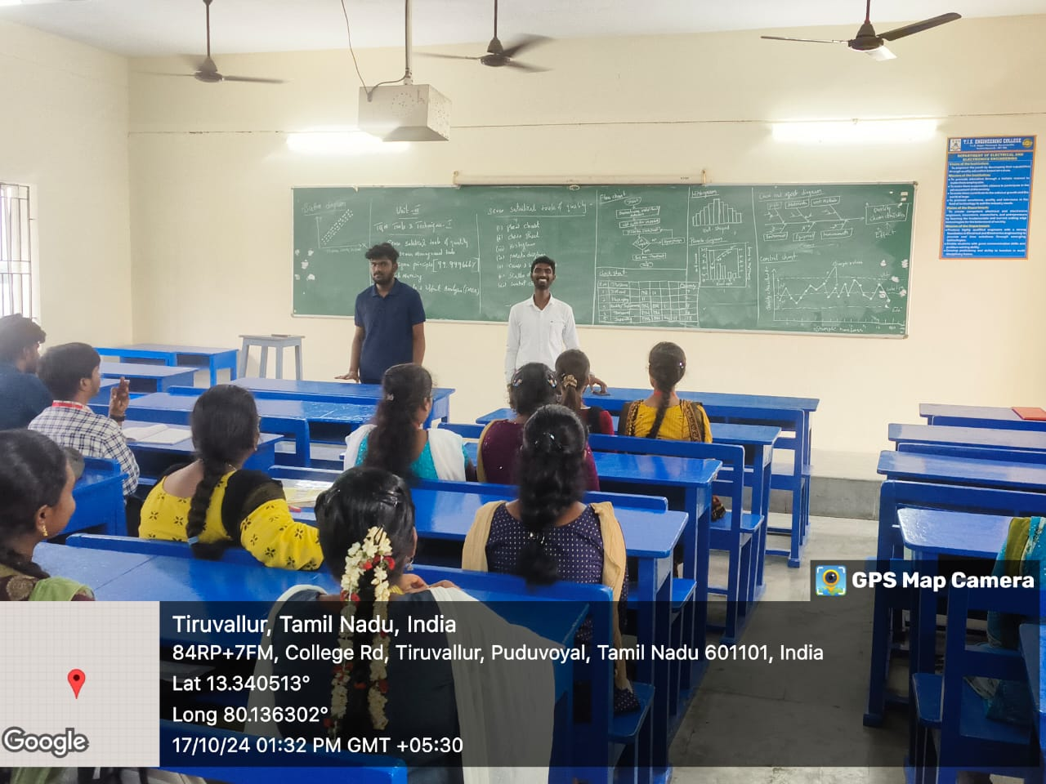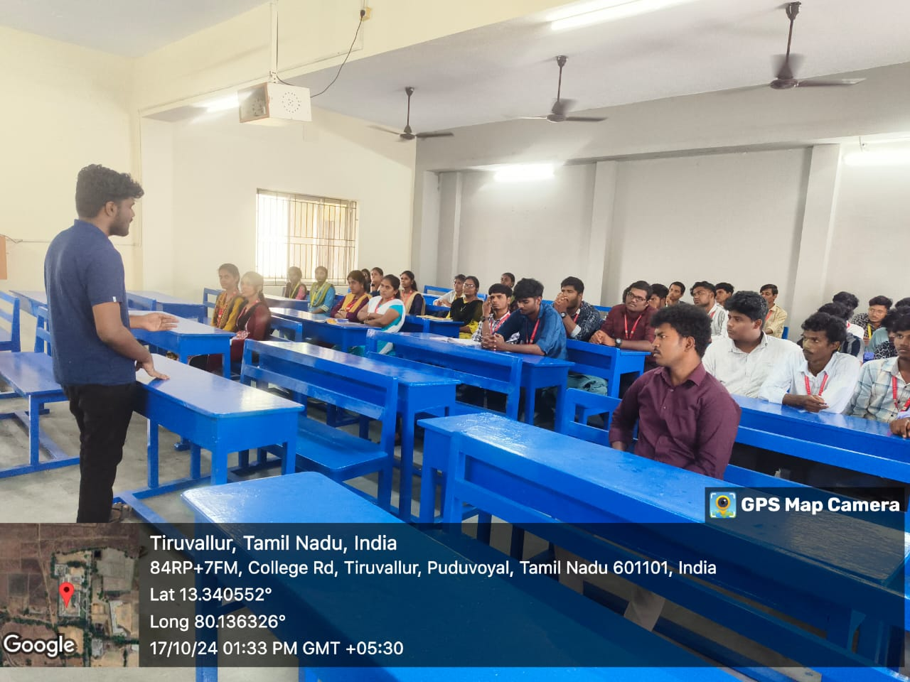

18-10-2024
II & III & IV year students has been attended the INDUSTRIAL VISIT on AXIS GLOBAL INSTITUTE OF INDUSTRIAL TRAINING in Guindy for the workshop on ROBOTICS & AUTOMATION FOR INDUSTRY with the coordination of
- GANESH - AP/EEE
- NEELAGANDAN - LI/EEE
- SHANMUGARAJ - LI/EEE
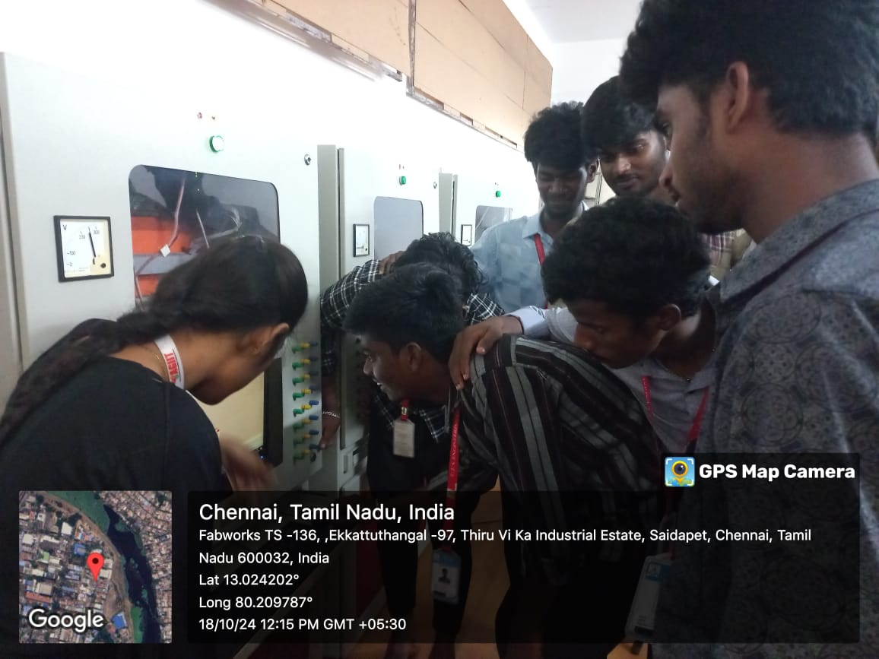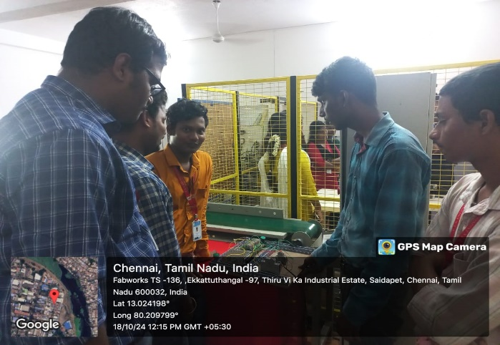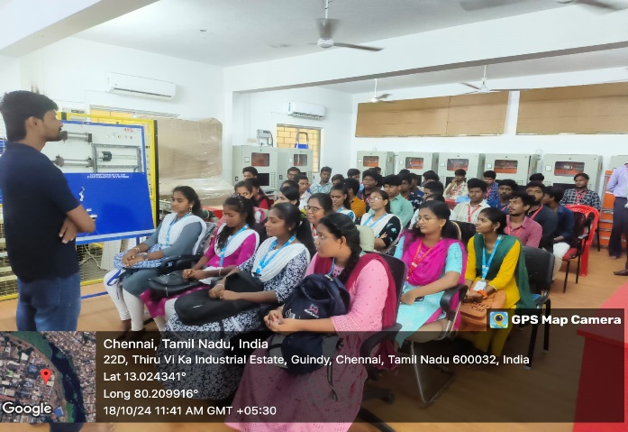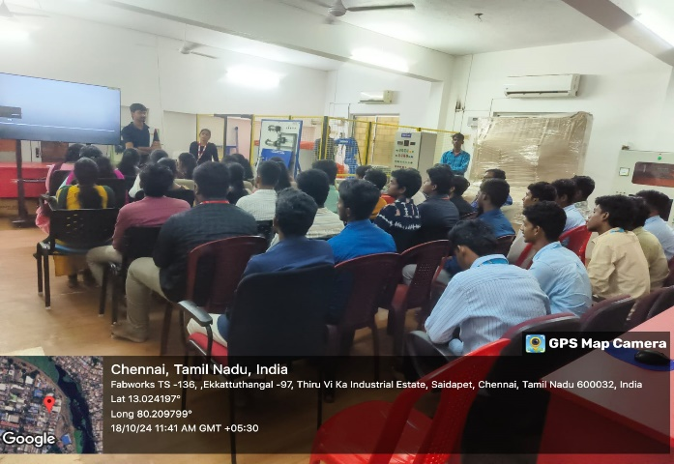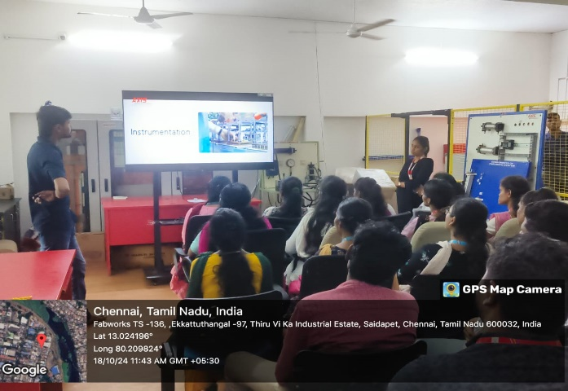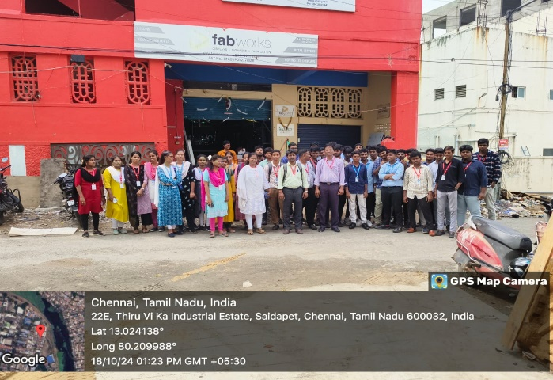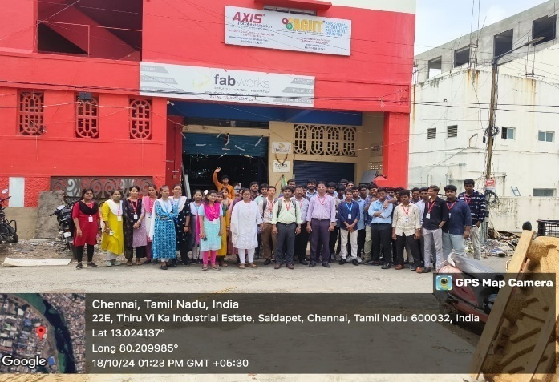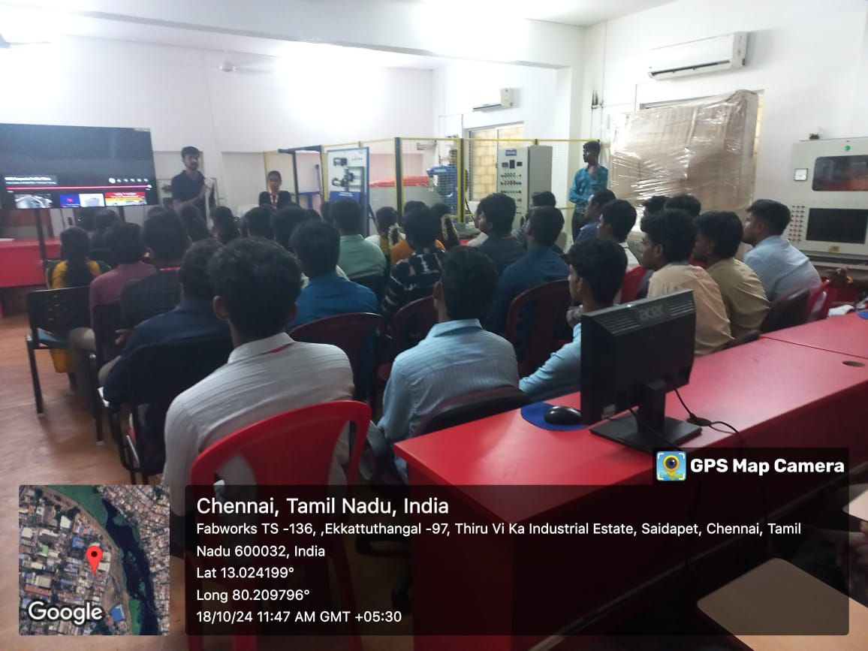

21-10-2024
IV year students has been attended the NAAN MUDHALVAN course in Vellammal College of Engg & Tech in Thatchoor with the co-ordination of NEELAGANDAN - LI/EEE
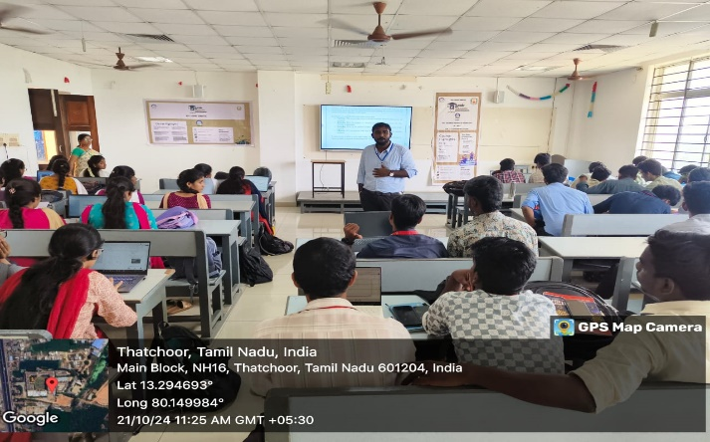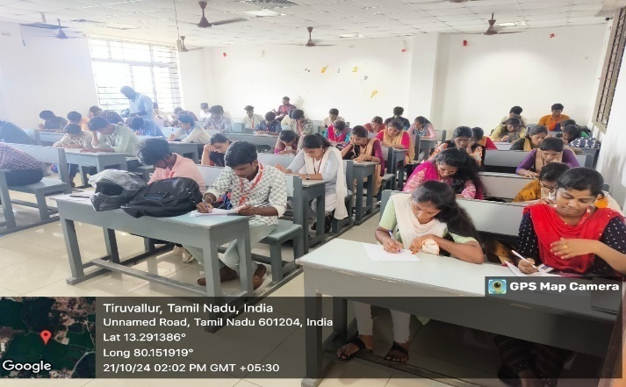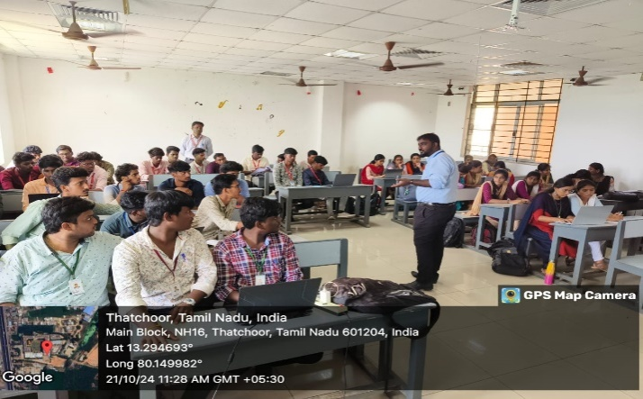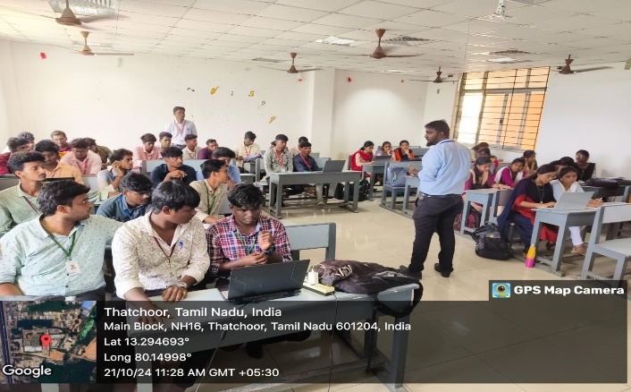

22-10-2024
III year students attended SEMINAR for GLOBAL TECH in online with the coordination of GANESH – AP/EEE
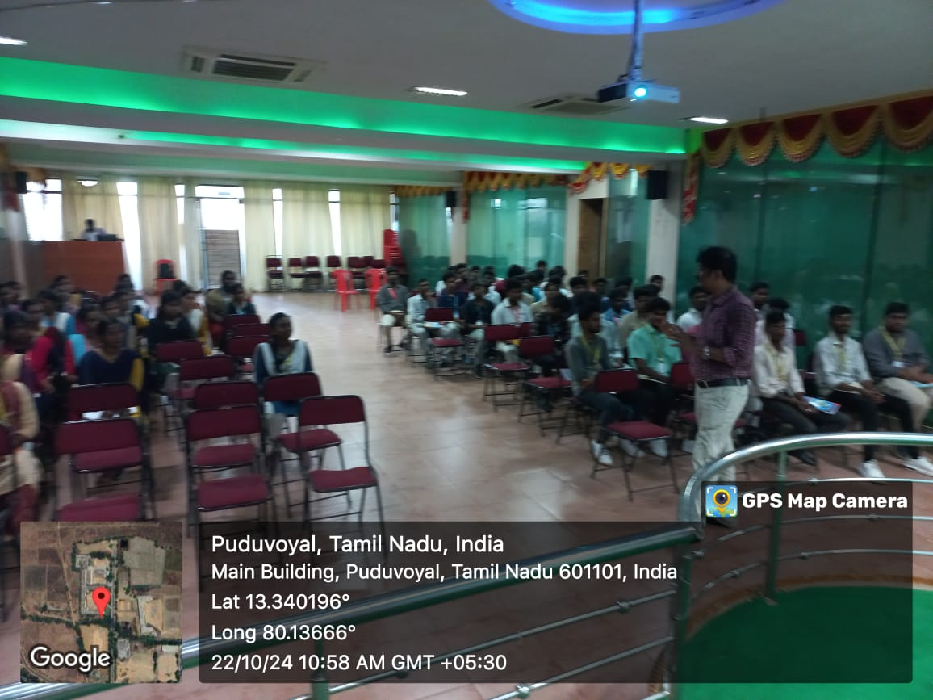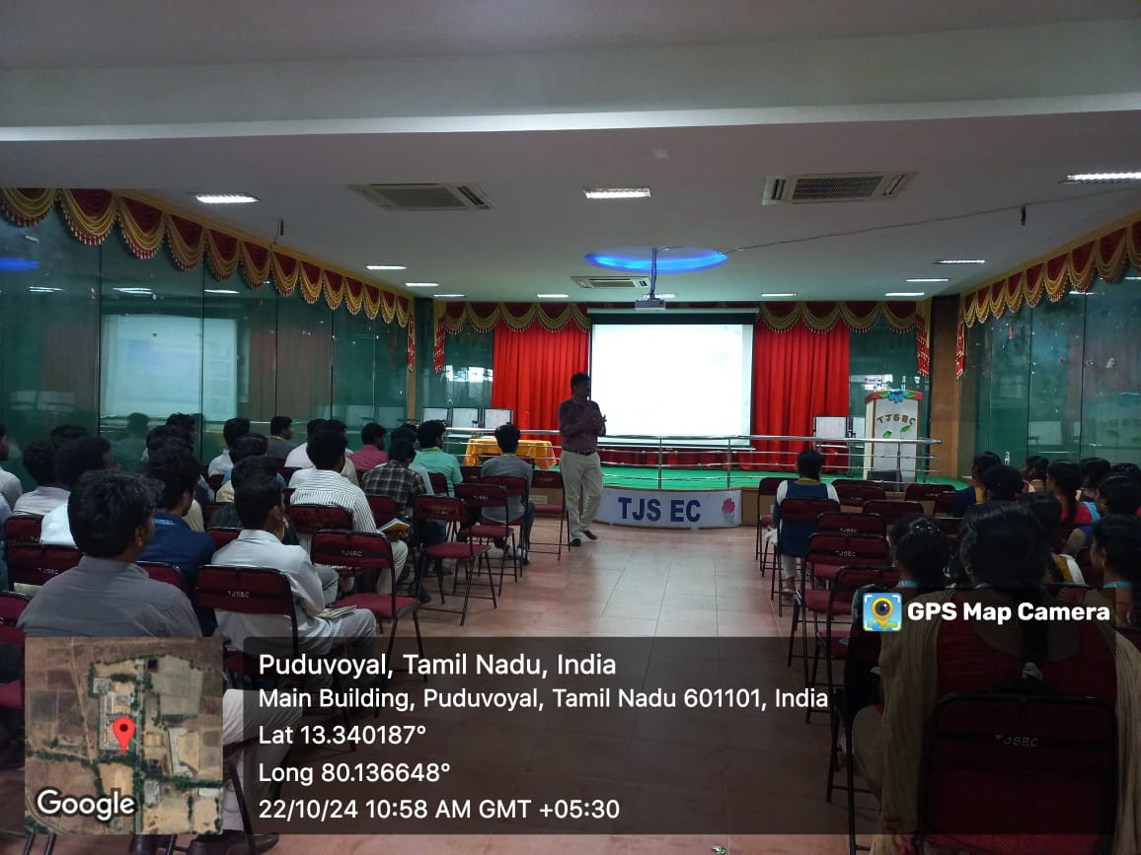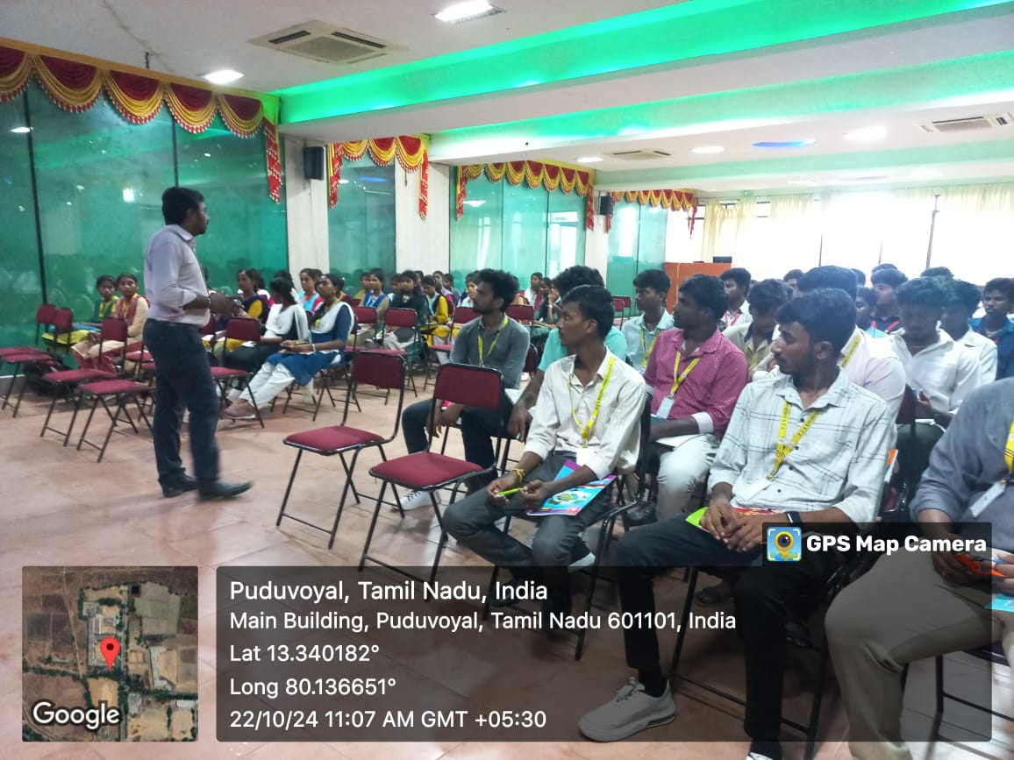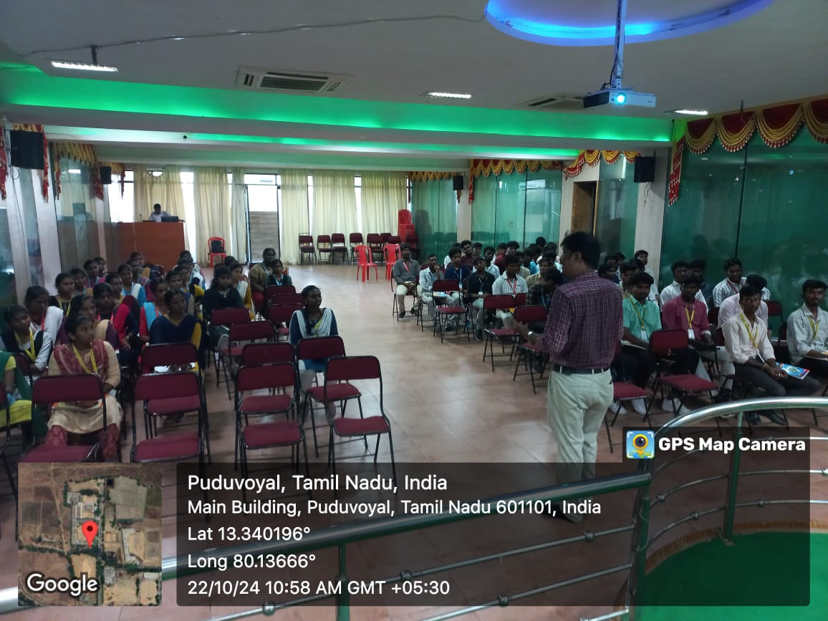

22-10-2024 & 24-10-2024 & 25-10-2024
II year students attending the PSSC Virtual Power-up Programme based on Power Sector with the coordination of MR.ANANTHARAMAN (PROLIFIC)
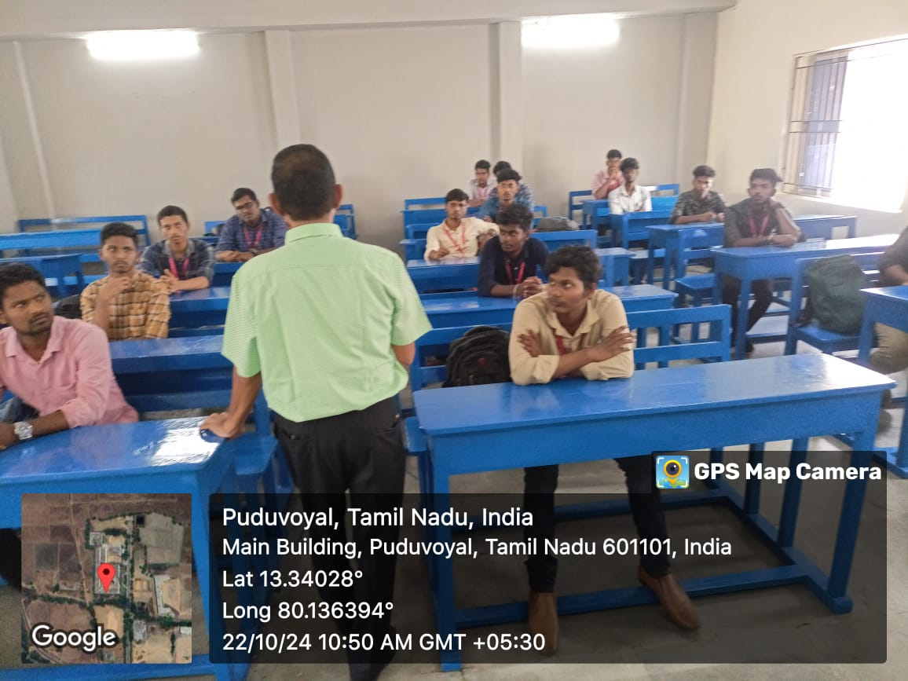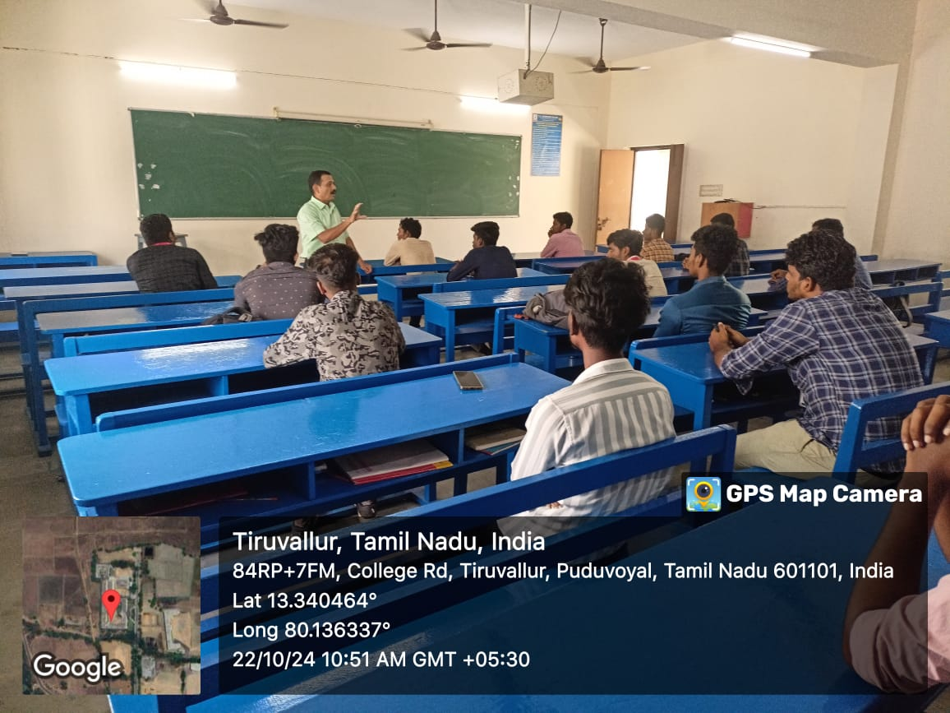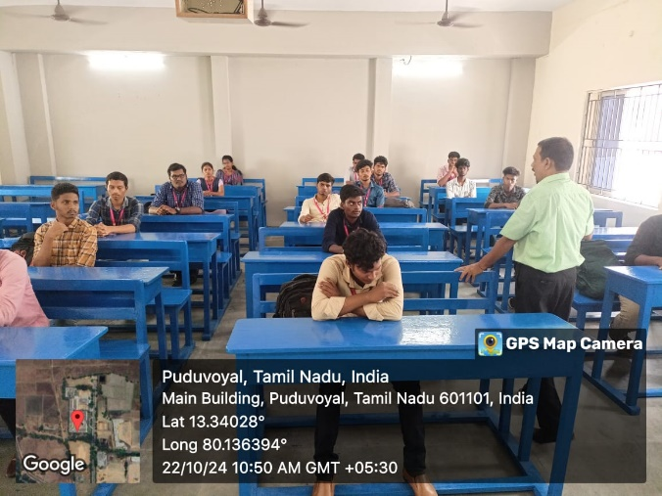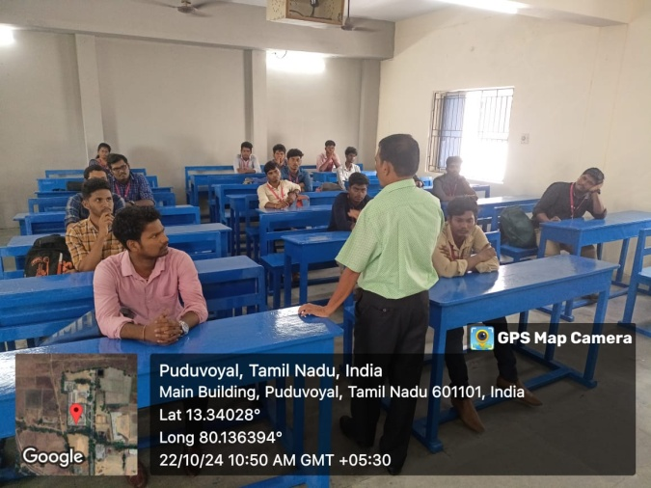

28-10-2024
IV year students has been attended the NAAN MUDHALVAN course in Vellammal College of Engg & Tech in Thatchoor with the co-ordination of NEELAGANDAN - LI/EEE
29-10-2024
One Day Workshop On Industrial Automation & Robotics conducted by AGIIT, Chennai students from II,III & IV year EEE students have participated

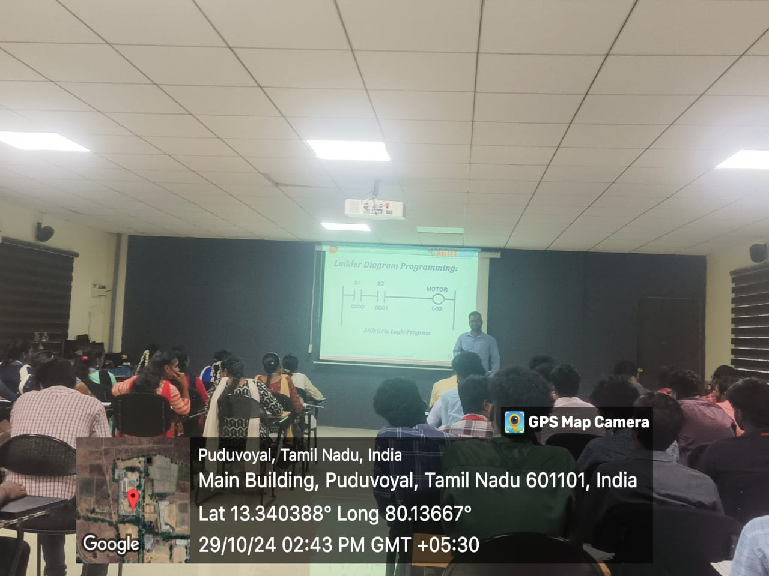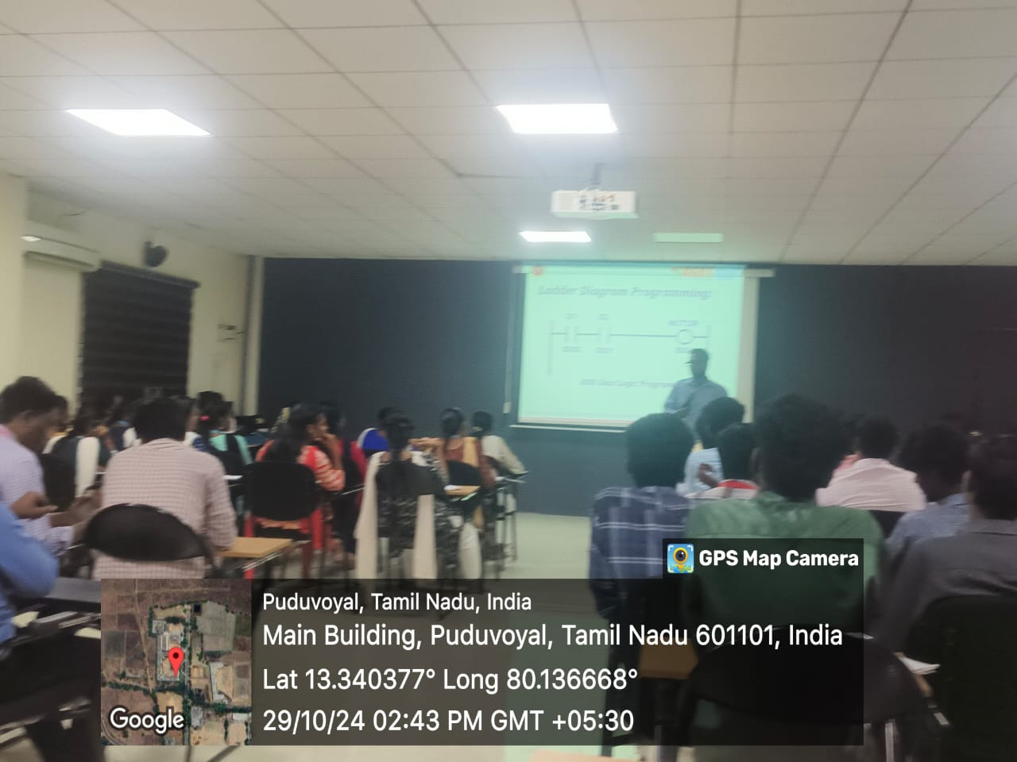
25-11-2024
- Alumni meet-up arranged for 2nd , 3rd and 4th year students of EEE dept. by Naresh kumar & Sathish kumar
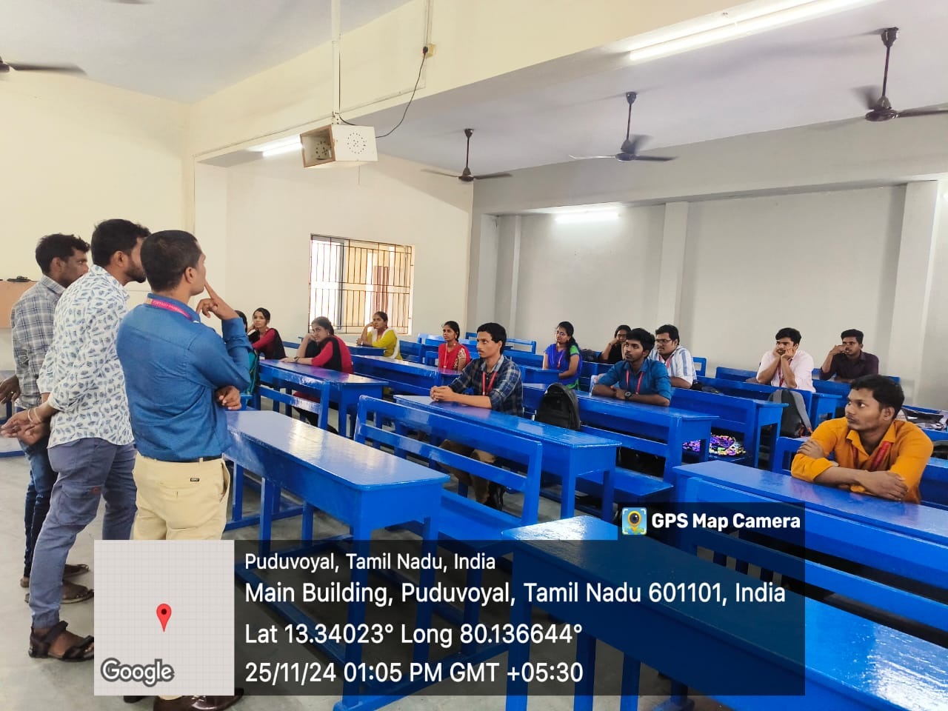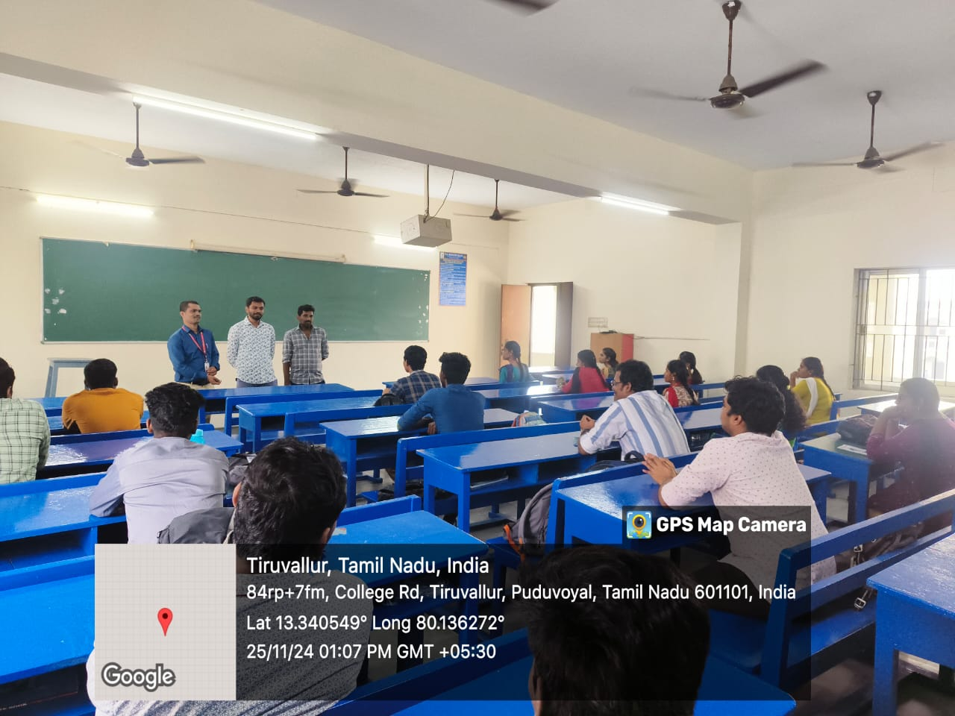

25-11-2024 TO 30-11-2024
FDP organized by Dept of Computer Applications, Periyar maniammai Inst of Science & Tech (PMIST), Vallam of ONE WEEK NATIONAL LEVEL FDP on RECENT ADVANCEMENTS IN AI & IOT – INDUSTRY PERSPECTIVE attended by
Ms. M. SHUNMUGA SHANKARI - HOD/EEE
Mr. T. KAMAL KUMAR – AP/EEE
Mr. M. ARJUN KUMAR – AP/EEE
Mr. S. GANESH – AP/EEE
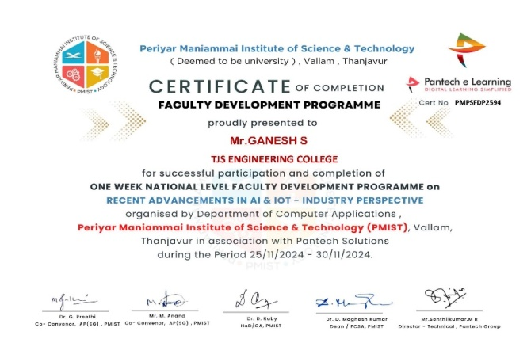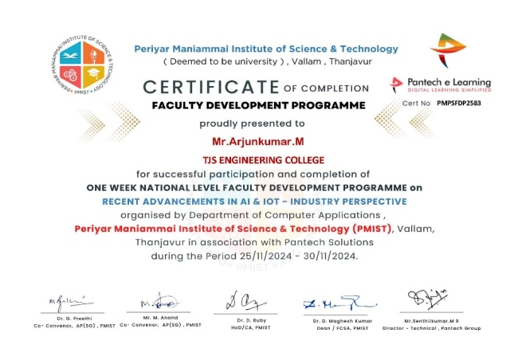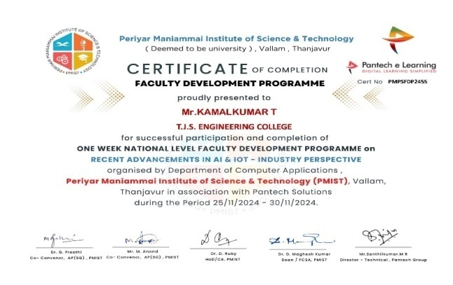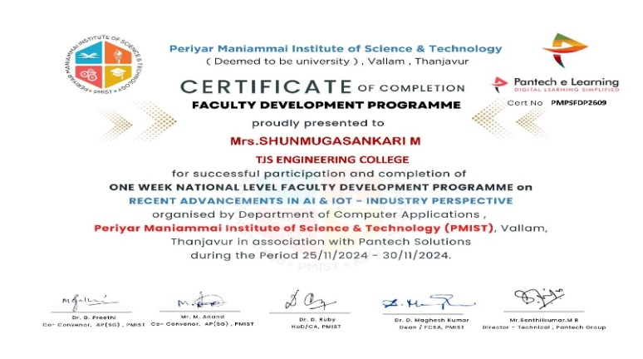

07-12-2024
Gaddam Sathish (11281115011) Sr. System Administration (Aquarelle India, Bangalore) Alumini meet-up for II & III year students of EEE Dept.
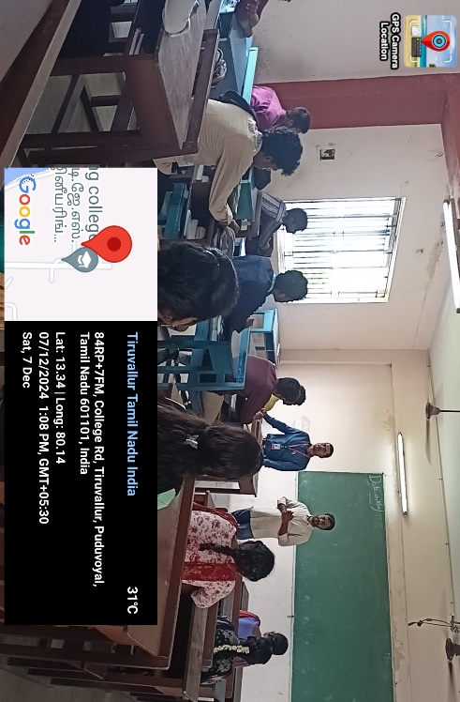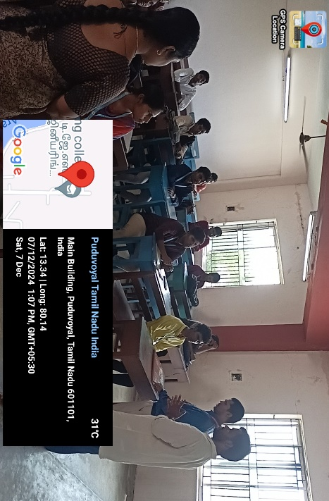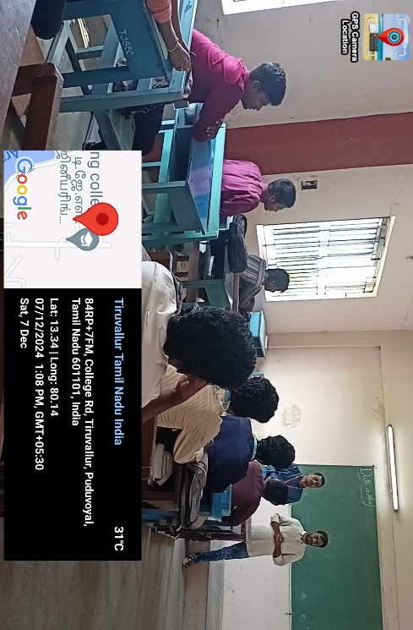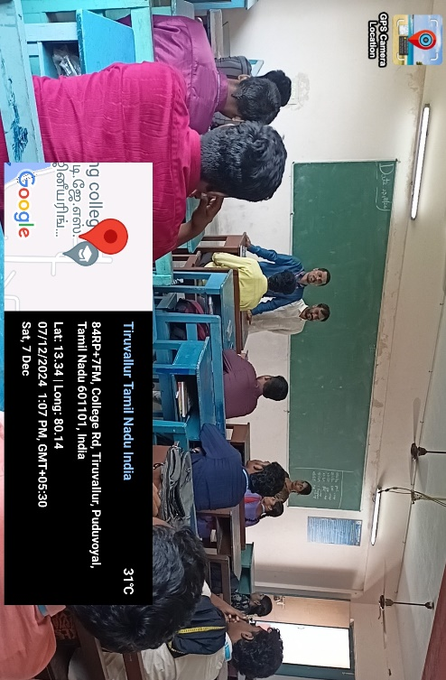

16.12.2024 TO 21.12.2024
FDP organized by Mailam Engg College Villupuram on “6-day Faculty Development Programme on “Smart Grid and Smart Distribution System“ attended by
Mrs.M.Shunmuga Sankari – HOD/EEE
Mr.T.Kamalkumar – AP/EEE
Mr. M. Arjunkumar – AP/EEE
Mr. S. Ganesh – AP/EEE

16.12.2024 TO 21.12.2024
FDP organized by ATAL – SRI KRISHNA COLLEGE OF ENGG & TECH , COIMBATORE on “CLIMATIC CRISIS AND MITIGATION BY SUSTAINABLE DEVELOPMENT OF ENERGY AND ENVIRONMENT SYSTEMS“ attended by
Dr. J. Prakash – Principal
Mrs.M.Shunmuga Sankari – HOD/EEE
Mr.T.Kamalkumar – AP/EEE
Mr. M. Arjunkumar – AP/EEE
Mr. S. Ganesh – AP/EEE

27-01-2025 TO 10-02-2025
INTERNSHIP conducted by Prolific Systems & Technologies Pvt. Ltd. for II Year EEE Students
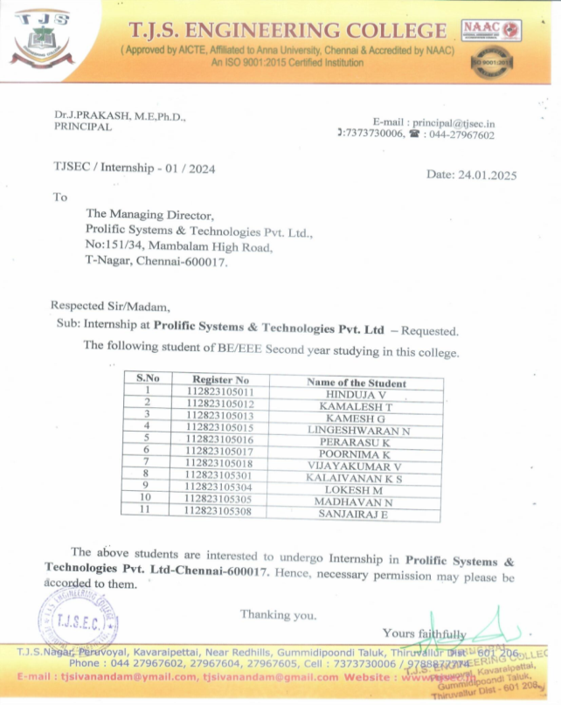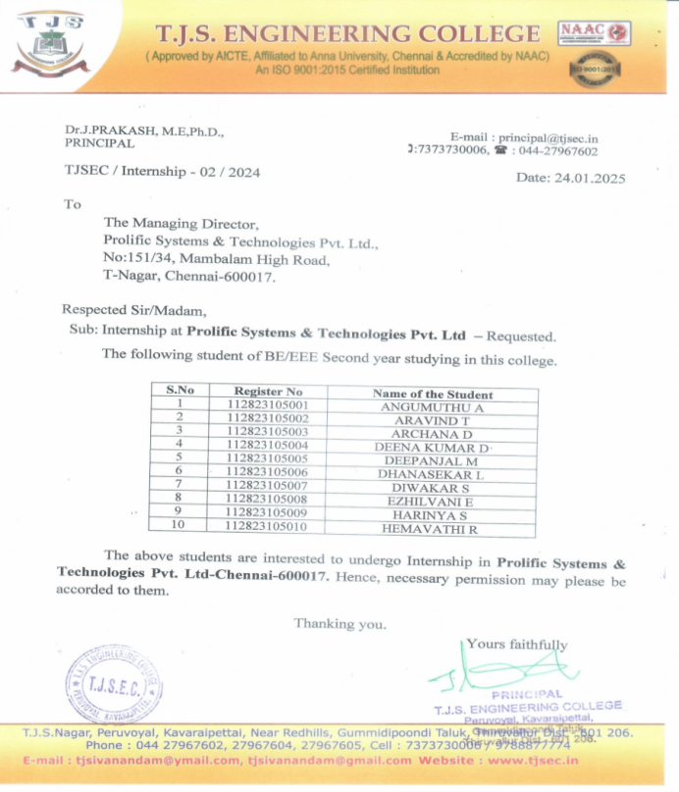

21-01-2025
IV year students has been attended the NAAN MUDHALVAN course - Niral Thiruvizha 2.0 at T.J.S. Engineering college, Peruvoyal
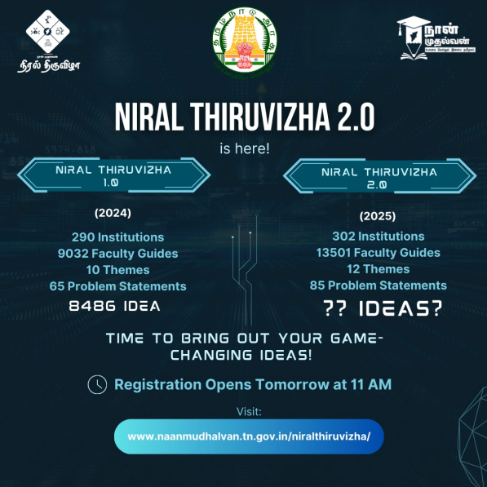

21-01-2025
II, III&IV year EEE Students attended GUEST LECTURE by Mr.Anandharaman (Prolific)
